# Visvesvaraya Technological University

## Belagavi, Karnataka-590 018



###### A Mini Project Report on

**“Movie Ticket Reservation System”**

###### Mini Project Report submitted in partial fulfillment of the requirement for the award of the degree

**Bachelor of Engineering in Information Science and Engineering**

Submitted by,

**Aarya Karthikeyan**

**1MJ17IS001**

Under the esteemed guidance of **Dr. Mannar Mannan Associate Professor**



## M V J College of Engineering, Bengaluru-67

**Department of Information Science and Engineering 2019-2020**

## M V J College of Engineering, Bengaluru-67

**Department of Information Science and Engineering 2019-20**



## CERTIFICATE

Certified that the project work titled **“MOVIE TICKET RESERVATION SYSTEM”** is a bonafide work carried out by **AARYA KARTHIKEYAN (1MJ17IS001)** in partial fulfillment for the award of Bachelor of Engineering in Information Science and Engineering of the Visvesvaraya Technological University, Belagavi during the academic year 2019-20. It is certified that all corrections and suggestions indicated for Internal Assessment have been incorporated in the report. The report has been approved as it satisfies the academic requirements in respect of Project Work prescribed for the Bachelor of Engineering Degree.

|  |  |  |
| --- | --- | --- |
| **Signature of Guide**  **Dr. Mannar Mannan Associate Professor** |  | **Signature of HOD Mrs. Sanchari Saha**  **Associate Professor & HOD** |
| **Dept. of ISE** |  | **Dept. of ISE** |
| **MVJCE** |  | **MVJCE** |
| **Sl.no** | **Examiners** | **Signature with date** |
| **1** |  |  |
| **2** |  |  |

## M V J College of Engineering, Bengaluru-67

**Department of Information Science and Engineering 2019-20**



## DECLARATION

I, **AARYA KARTHIKEYAN (1MJ17IS001)** hereby declare that the dissertation entitled, **“MOVIE TICKET RESERVATION SYSTEM”** has been completed and written by me under the supervision of Dr Mannar Mannan, Associate Professor, Department of Information Science and Engineering, MVJCE, Bangalore, in partial fulfillment of the requirements for the award of the degree of Bachelor of Engineering in Information Science and Engineering, of Visvesvaraya Technological University, Belagavi. The dissertation report is original and it has not been submitted for any other degree in any university.

Date: AARYA KARTHIKEYAN

Place: (1MJ17IS001)

### ACKNOWLEDGEMENT

The satisfaction that accompanies the successful completion of this project report would be incomplete without the mention of people who made it possible, without whose constant guidance and encouragement, would have made efforts go in vain. I consider ourselves privileged to express gratitude and respect towards all those who guided us through the completion of this project.

I am grateful to **Mrs. Sanchari Saha**, Associate Professor and HOD, Information Science and Engineering, for giving the support and encouragement that was necessary for the completion of this project. In this context, I would also like to thank all the other staff members, both teaching and non-teaching, who have extended their timely help and eased our task.

I, also convey thanks to my project guide **Dr. Mannar Mannan**, Associate Professor, Department of Information Science and Engineering, for providing encouragement, constant support and guidance which was of great help to complete this project work successfully.

I would like to express my heart-felt gratitude to my parents and friends for their continued moral and material support throughout the course and in helping me finalize the project report.

AARYA KARTHIKEYAN

# ABSTRACT

A Movie Ticket Reservation System is a C++ programming based ticket reservation system allowing bookings in a few easy steps. This project is aimed to provide the customers facility to book tickets for cinema halls offline.

Movie ticket booking system is basically has information about the movies offline. The user can easily be able to know about the movies released and then make the choice.

In this project Admin can insert and delete data (e.g. film description, book ticket, delete movie ticket, modify movie, search movie). This project eliminates the paper work, human faults, manual delay and speeds up process

.

Drug Store Management System will have the ability to track sales and availability of medicines, it tells a drug storeowner when it's time to reorder so he/she can purchase more medicines.

The system provides many features, these include secured encrypted password login for admin that is the drug storeowner. Admin can add new medicine, search for medicine and remove medicine, admin can add new manufacturers, search for manufacturers and remove manufacturers, admin can view the list of medicines and manufacturers currently available. Admin can generate bills on the multiple medicines bought by the customers. admin can track available medicine stocks quantity, admin can view all the bills that was generated by date and also a view of medicine purchases made by the drug store to respective manufacturers for restock purposes. Hence this is a flexible drug store management system.

**TABLE OF CONTENTS**

|  |  |  |
| --- | --- | --- |
| 1 | Acknowledgement | I |
| 2 | Abstract | II |
| 3 | Table of Contents | III |
| 4 | List of Figures | V |
| **Sl. No.** | **Title** | **Page No.** |
| 1 | Introduction | 1 |
|  | 1.1 Problem statement | 1 |
| 2 | Analysis and System Requirements | 4 |
|  | 2.1 Proposed Solution | 4 |
| 2.2 System Configuration | 5 |
| 3 | System Design and Modelling | 6 |
|  | 3.1 Preliminary Design | 6 |
|  | 3.2 ER Diagram | 9 |
|  | 3.3 Schema Diagram | 10 |
| 3.4 Database Relation | 11 |
| 4 | Implementation | 16 |
|  | 4.1 Flow Chart, Context Flow model and Data Flow Model | 16 |
| 4.2 Module 1-Backend | 17 |
| 4.3 Module 2-Frontend | 18 |
| 4.4 Source code | 20 |

|  |  |  |
| --- | --- | --- |
| 5 | Screenshots | 26 |
|  | Figure 1 Home page | 26 |
| Figure 2 About the store page | 27 |
| Figure 3 Admin login page | 27 |
| Figure 4 Contact us for complaint page | 28 |
| Figure 5 Admin Login main page | 28 |
| Figure 6 Admin search medicine page | 29 |
| Figure 7 Admin Operations(add,delete) page | 29 |
| Figure 8 Add medicine page | 30 |
| Figure 9 Add manufacturer page | 30 |
| Figure 10 Deletion page | 31 |
| Figure 11 Medicine details page | 32 |
| Figure 12 Bill generation page | 32 |
| Figure 13 Bill details page | 33 |
| Figure 14 Admin reports access page  Figure 15 Medicine report details page  Figure 16 Admin buy medicines for store page | 33  34  34 |
| 6 | Testing | 34 |
|  | 6.1 Introduction to Testing | 34 |
| 7 | Conclusion | 36 |
|  |  |  |

**LIST OF FIGURES**

**FIG NO. TITLE PAGE NO.**

|  |
| --- |
| Figure 1 Home page |
| Figure 2 About the store page |
| Figure 3 Admin login page |
| Figure 4 Contact us for complaint page |
| Figure 5 Admin Login main page |
| Figure 6 Admin search medicine page |
| Figure 7 Admin Operations(add,delete) page |
| Figure 8 Add medicine page |
| Figure 9 Add manufacturer page |
| Figure 10 Deletion page |
| Figure 11 Medicine details page |
| Figure 12 Bill generation page |
| Figure 13 Bill details page |
| Figure 14 Admin reports access page  Figure 15 Medicine report details page  Figure 16 Admin buy medicines for store page |

26

26

27

27

28

28

29

29

30

30

31

32

32

33

33

34

34

**Chapter 1**

**INTRODUCTION**

##### Preamble

Drug Store management system is a computerized management system. This system helps in maintaining the databases of a pharmaceutical shop. This is done by creating a database of the available medicines in the shop .This project has GUI based software that will help in storing (adding) , searching and retrieving the information through various user-friendly menu-driven modules.

The projects aim is to develop software for the effective management of a pharmaceutical store. We have developed this software to ensure effective information about the drugs in stock. Main objective of this project is to provide information about the medicines and manufacturers using computerized process for having proper details to improve accuracy and enhance safety and efficiency in the pharmaceutical store. This software application will help admin to handle these information. Detailed explanation about modules and design are provided in project documentation. The existing system is a manually maintained system. All the medicines, manufacturers, bills records are maintained. All these details are entered and retrieved manually, because of this there are many disadvantages like:

1. Time Consuming

2. Exhaustive and inefficient updating process

3.Inaccuracy of data and room for human error in manual entry

For avoiding this we introduced or proposed a new system in proposed system the computerized version of the existing system which provides easy and quick access over the data.

##### PROBLEM STATEMENT

In the existing manual system, a lot of time is spent in manually recording information about each and every medicine. The current world still works on the traditional, orthodox system of written entries of the registration and manually submitting all the information for purchasing or restocking purposes which is tedious and inefficient.

There are more chances for the people involved in the system to create errors, and this old-fashioned method also takes a long time to execute manually, even after not considering the high chances of mistakes

Also, due to the constant changing of the market, it will lead to proportionate changes to the cost of medicines, which makes updating them dynamically everywhere tough .Therefore all the old techniques proves to be inefficient and a mammoth task, and we need to overcome this.

There is a need for an integrated automated system, which has some centralized control over the entire process. Conventional System makes use of huge amounts of paper for recording transactions. The existing system is a manually maintained system. All the medicine records, manufacturers records, bill details etc. All these details are entered and retrieved manually.

Disadvantages:

* + 1. Time consuming.
    2. Inaccuracy of data.
    3. More prone to errors when being manipulated manually

Implementation using user type:

1. **Admin**

* **ADMIN MODULE:**

This module only provides administrator (of the drug store) related functionalities. The admin can login only after providing a valid admin id, admin name and password.

Administrator can view medicine currently available , can view all the manufacturers details , has access to all the customers who have purchased medicines from the store via the bill records.

Also purchase medicines from manufacturer for restocking purposes.

This module also requires the admin logged in to keep all the medicine information confidential and not disclose it to any other third party, not compromising the data to unauthorized access.

**Chapter 2**

**ANALYSIS AND SYSTEM REQUIREMENTS**

##### PROPOSED SOLUTION

Proposed system is a computerized version of the existing system which provides easy and quick access over the data keeping records of the drug store so that the system is much more efficient.

Advantages:

* + 1. Storing medicines, manufacturers and bill details properly
    2. Maintains accuracy of data and reducing errors
    3. Reducing manual paper works and a very easy to use system

OBJECTIVES

“Drug Store Management System” has been designed to be computerized and utmost care has been taken to make the system efficient and user friendly.It includes the functionalities for entering and retrieving the following details:

* + - 1. Medicines , manufacturers Details (accessible only by the admin)
      2. Adding a new medicine or a new manufacturer.
      3. Create a new bill using the billing system.
      4. Removing a medicine or a manufacturer.
      5. Billing details of customers who have previously come to buy the medicine from the store.
      6. Buy new medicines from manufacturers for restocking purposes.
      7. A medicine log on various medicines added or removed.
      8. A manufacturer log on various manufacturers added or removed

##### SYSTEM CONFIGURATION

H/W System Configuration:

* Processor - Pentium –III
* Speed - 1.1 GHz
* RAM - 256 MB (min)
* Hard Disk - 20 GB (min)
* Floppy Drive - 1.44 MB
* Key Board - Standard Windows Keyboard
* Mouse - Two or Three Button Mouse
* Monitor - SVGA

S/W System Configuration: -

* Operating System - Windows95/98/2000/XP/8.1/10
* Application Server - Apache
* Front End - HTML, CSS, Bootstrap
* Back End - PHP
* Database Connectivity - MySQL
* Connecting front end and back end - PHP

#### Chapter 3

**SYSTEM DESIGN AND MODELLING**

##### PRELIMINARY DESIGN:

ENTITY RELATIONSHIP DIAGRAM (ERD)

**Entity – Relationship Diagram:** This depicts relationship between data objects. The attribute of each data objects noted in the entity- relationship diagram can be described using a data object description. Data flow diagram serves two purposes:

* + 1. To provide an indication of how data are transformed as they move through the system.
    2. To depict the functions that transformation the data flow.

**The basic components of entity relationship diagram/model are listed and defined below: Data Objects:** A data object is a representation of almost any composite information that must be understood by the software. By composite information, we mean something that has a number of different properties or attributes. A data object encapsulates data only there is no reference within a data object to operations that act on the data.

**Attributes:** Attributes define the properties of a data object and take on one of three different characteristics

They can be used to:

* + - * Name an instance of data object.
      * Describe the instance.
      * Make reference to another instance in other table.

**Relationships:** Data objects are connected to one another in a variety of different ways. We can define a set of object relationship pairs that define the relevant relationships.

CARDINALITY AND MODALITY:

**Cardinality:**

The data model must be capable of representing the number of occurrences of objects in a given relationship. The cardinality of an object relationship pair is

 **One-T0-One (1:1):** An occurrence of object ‘A’ can relate to one and only one occurrence of object ‘B’ and vice versa.

 **One-To-Many (1: N):** One occurrence of object ‘A’ can relate to one or may occurrences of object ‘B’ but an occurrence of object ‘B’ can relate to only one occurrence of object ‘A’**.**

 **Many-To-Many (M: N):** An occurrence of ‘B’ and an occurrence of

‘B’can relate to one or many occurrences of

‘A’.

Modality:

The modality of a relationship is zero if there is no explicit need for the relationship to occur or the relationship is optional. The Modality isone if the occurrence of the relationship is mandatory.

The object relationship pair can be represented graphically using the Entity Relationship Diagrams.

A set of primary components are identified for the Entity Relationship Diagram,

1. Attributes,
2. Relationships and
3. Various Type Indicators.

The primary purpose of the Entity Relationship Diagram is to represent data objects and their relationships.

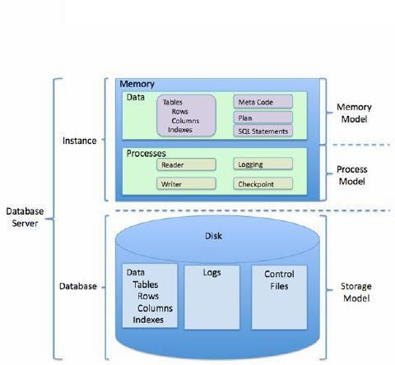

Fig 3.1: Relational DBMS diagram (structure used in this project)

* 1. **ER DIAGRAM:**

**Fig 3.2: Entity Relationship Diagram:**

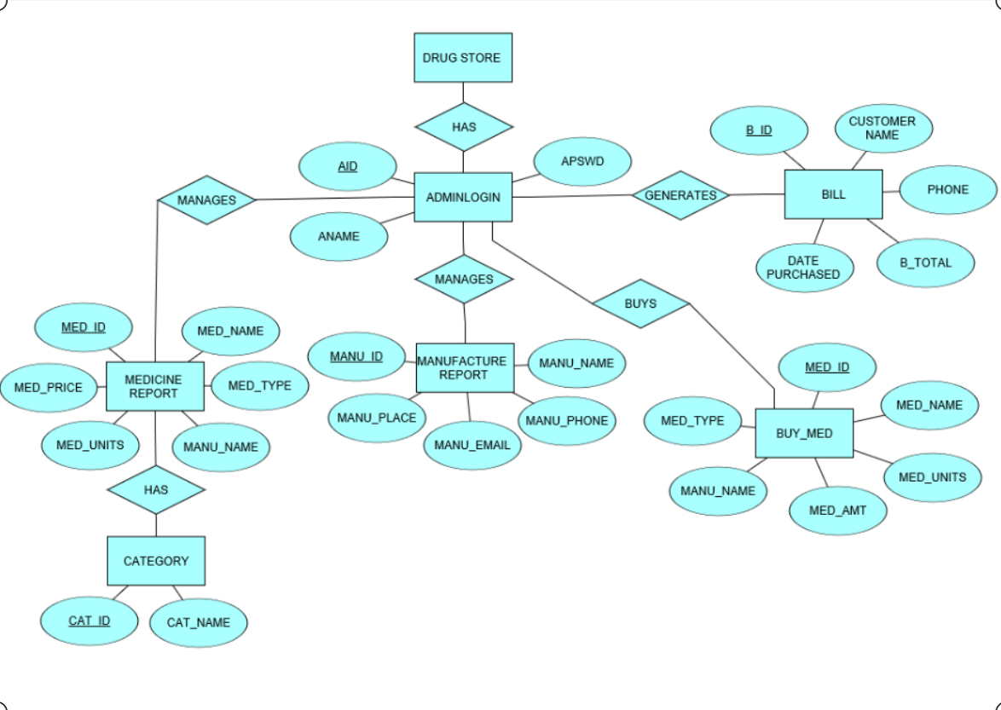

* 1. **SCHEMA DIAGRAM:**

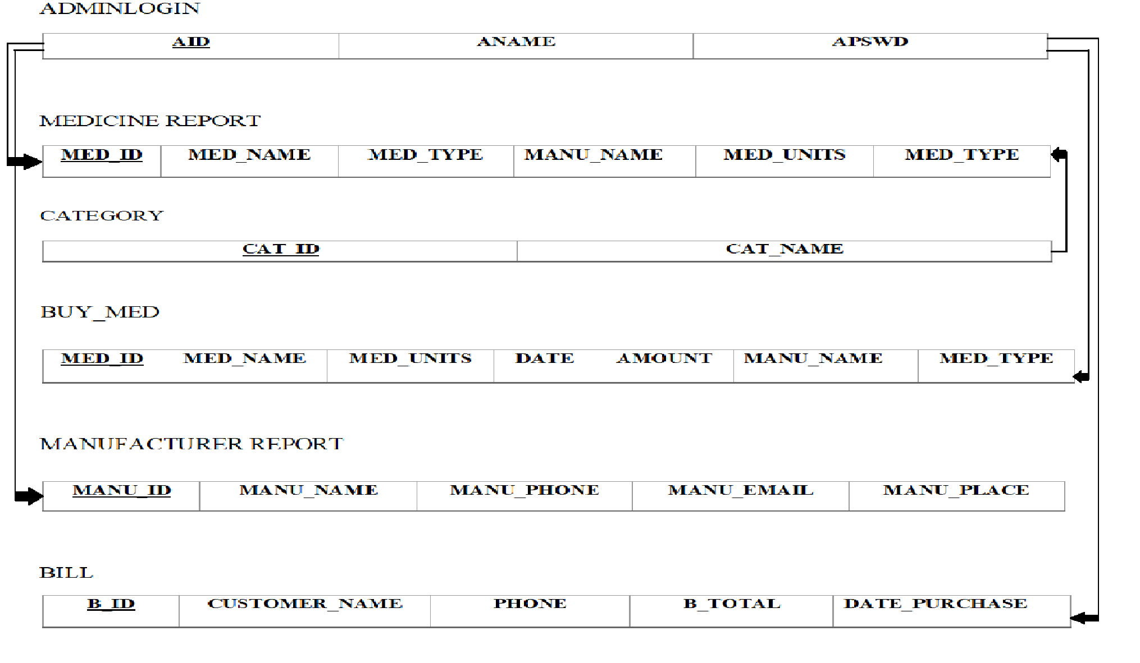

Fig 3.3: Schema Diagram

* 1. **DATABASE RELATIONS**

**Drug store management system** consists of six tables. It is used by admin to store and retrieve details regarding medicine, manufacturers and bills.

The database uses the following tables for maintaining the details:

* Admin
* Medicines
* Manufacturers
* Bills of customers
* Bills of medicines bought by the store

The description of the tables is as follows:

Table 3.1 **ADMINLOGIN:** This table consists of details of the admin.

|  |  |  |  |
| --- | --- | --- | --- |
| COLUMN NAME | DATATYPE AND SIZE | CONSTRAINTS | DESCRIPTION |
| AID | **INT(11)** | **PRIMARY KEY** | The aid accepts the integer which is used to identify the admin. |
| ANAME | **VARCHAR(20)** | **NOT NULL** | Name of admin. |
| APSWD | **VARCHAR(50)** | **NOT NULL** | Password of the admin. |

Table 3.2 **CATEGORY:** This table consists of the category of medicines.

|  |  |  |  |
| --- | --- | --- | --- |
| COLUMN NAME | DATATYPE AND SIZE | CONSTRAINTS | DESCRIPTION |
| CAT_ID | **INT(11)** | **PRIMARY KEY** | Id of the category. |
| CAT_NAME | **VARCHAR(20)** | **NOT NULL** | Name of category. |

Table 3.3 **MEDICINE_REPORT:** This table consists of all the details of medicines.

|  |  |  |  |
| --- | --- | --- | --- |
| COLUMN NAME | DATATYPE AND SIZE | CONSTRAINTS | DESCRIPTION |
| MED_ID | **INT(11)** | **PRIMARY KEY** | Id of the medicine. |
| MED_NAME | **VARCHAR(50)** | **NOT NULL** | Name of medicine. |
| MED_TYPE | **VARCHAR(20)** | **NOT NULL** | Type of medicine. |
| MANU_NAME | **VARCHAR(50)** | **NOT NULL** | Manufacturer of the medicine. |
| MED_UNITS | **INT(11)** | **NOT NULL** | Total units of medicine available. |
| MED_PRICE | **INT(11)** | **NOT NULL** | Cost of that medicine. |

Table 3.4 **MANUFACTURER_REPORT:** This table consists of the details of all the manufacturers.

|  |  |  |  |
| --- | --- | --- | --- |
| COLUMN NAME | DATATYPE AND SIZE | CONSTRAINTS | DESCRIPTION |
| MANU_ID | **INT(11)** | **PRIMARY KEY** | Id of the manufacturer. |
| MANU_NAME | **VARCHAR(50)** | **NOT NULL** | Name of the manufacturer. |
| MANU_PHONE | **INT(10)** | **NOT NULL** | Phone number of the manufacturer. |
| MANU_EMAIL | **VARCHAR(50)** | **NOT NULL** | Email of the manufacturer. |
| MANU_PLACE | **VARCHAR(20)** | **NOT NULL** | Address of the manufacturer. |

Table 3.5 **BILL:** This table consists of the billing details of all the customers that have visited the drug store.

|  |  |  |  |
| --- | --- | --- | --- |
| COLUMN NAME | DATATYPE AND SIZE | CONSTRAINTS | DESCRIPTION |
| B_ID | **INT(11)** | **PRIMARY KEY** | Id of the bill. |
| CUSTOMER_NAME | **VARCHAR(50)** | **NOT NULL** | Name of the customer of that bill. |
| PHONE | **INT(10)** | **NOT NULL** | Phone number of the customer. |
| B_TOTAL | **VARCHAR(50)** | **NOT NULL** | Total amount the customer paid for the bill. |
| DATE_PURCHASE | **DATE** | **NOT NULL** | The date the bill was generated. |

Table 3.6 **BUY_MED:** This table consists of details of all the bills of the medicines that the store bought from manufacture.

|  |  |  |  |
| --- | --- | --- | --- |
| COLUMN NAME | DATATYPE AND SIZE | CONSTRAINTS | DESCRIPTION |
| MED_ID | **INT(11)** | **PRIMARY KEY** | Id of the medicine. |
| MED_NAME | **VARCHAR(50)** | **NOT NULL** | Name of the medicine. |
| MED_UNITS | **INT(50)** | **NOT NULL** | Number of units of medicine. |
| DATE | **DATE** | **NOT NULL** | Date of the purchase made to manufacturer. |
| MED_AMOUNT | **INT(50)** | **NOT NULL** | The total amount paid for buying all the medicines. |
| MANU_NAME | **VARCHAR(20)** | **NOT NULL** | Name of the manufacturer from which the medicines were brought. |
| MED_TYPE | **VARCHAR(20)** | **NOT NULL** | Type of medicine. |

#### Normalization

* Process for evaluating and correcting table structures to minimize data redundancies
  + Reduces data anomalies
* Works through a series of stages called normal forms:
* First normal form (1NF)
* Second normal form (2NF)
* Third normal form (3NF)

##### NF

Database is in first normal form, if it satisfies the following conditions

* 1. Contains only atomic values.
  2. There are no repeating groups.

##### NF

A relation schema R is in second normal form, if every non-primary attribute A is fully functionally Dependant on Primary key of R

* 1. It is in 1NF
  2. All non-key attributes are fully functionally dependant on primary key.

##### NF

1. It is in 2NF
2. there are no transitive functional dependencies The above tables satisfy all three normal forms

##### CHAPTER 4- IMPLEMENTATION

##### Flow Chart, Context Flow Model and Data Flow Model

A flowchart is a type of diagram that represents an algorithm, workflow or process, showing the steps as boxes of various kinds, and their order by connecting them with arrows. This diagrammatic representation illustrates a solution model to a given problem. Flowcharts are used in analyzing, designing, documenting or managing a process or program in various fields.

Flowcharts are used in designing and documenting simple processes or programs. Like other types of diagrams, they help visualize what is going on and thereby help understand a process, and perhaps also find flaws, bottlenecks, and other less-obvious features within it. There are many different types of flowcharts, and each type has its own repertoire of boxes and notational conventions. The two most common types of boxes in a flowchart are:

Fig4.1: Flow Chart

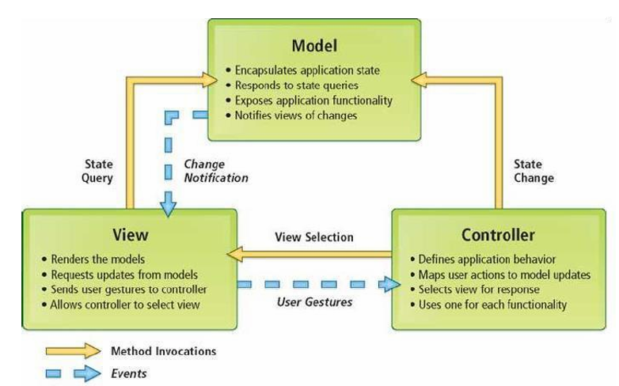

Fig4.2: Context flow model

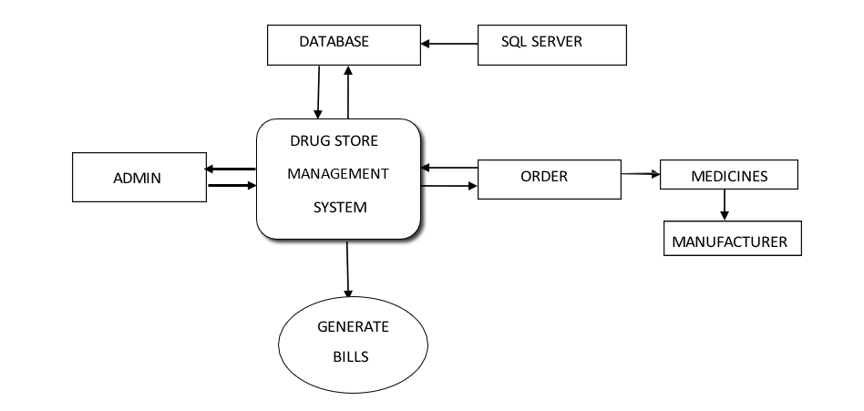

**Fig4.2: Data flow model** 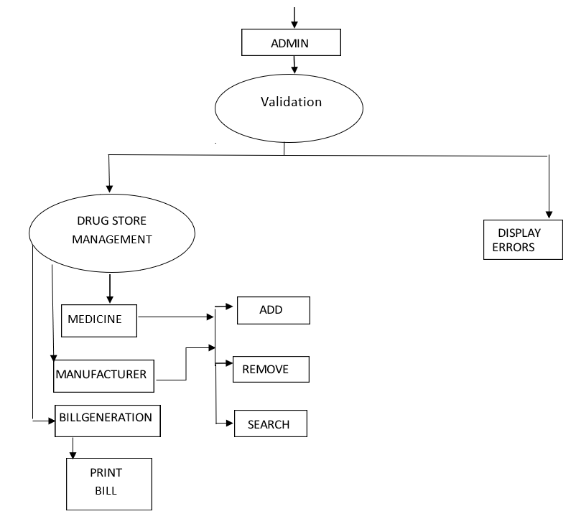

* 1. **MODULE 1 – BACKEND**
* **PHPMYADMIN**

PhpMyAdmin is used for connecting the database to the apache server.

**phpMyAdmin** is a [free and open source](https://en.wikipedia.org/wiki/Free_and_open_source) administration tool for [MySQL](https://en.wikipedia.org/wiki/MySQL) and [MariaDB.](https://en.wikipedia.org/wiki/MariaDB) As a portable [web](https://en.wikipedia.org/wiki/Web_application) [application](https://en.wikipedia.org/wiki/Web_application) written primarily in [PHP,](https://en.wikipedia.org/wiki/PHP) it is currently one of the most popular MySQL administration tools, especially for [web hosting services.](https://en.wikipedia.org/wiki/Web_hosting_service)

It has the following features:

* Intuitive web interface
* Support for most MySQL features
* Import data from CSV and SQL
* Export data to various formats: CSV, SQL, XML, PDF, ISO/IEC 26300 - OpenDocument Text and Spreadsheet, Word, Excel, LATEX and others
* Administering multiple servers
* Creating PDF graphics of your database layout
  + MY SQL

We have used, in this project , MySQL which is an [open-source](https://en.wikipedia.org/wiki/Open-source) [relational database management system.](https://en.wikipedia.org/wiki/Relational_database_management_system) MySQL is a central component of the LAMP open-source web application software stack (and other "AMP" stacks). LAMP is an acronym for "Linux, Apache, MySQL, Perl/PHP/Python". Applications that use the MySQL database include: TYPO3, MODx, Joomla, WordPress, phpBB, MyBB, and Drupal. MySQL is also used in many high-profile, large-scale websites, including Google (though not for searches), Facebook, Twitter, Flickr, and YouTube.

##### MODULE 2 – FRONTEND

We have used the following front-end languages:

* HTML

**Hypertext Mark-up Language** (**HTML**) is the standard [mark-up language](https://en.wikipedia.org/wiki/Markup_language) for creating [web pages](https://en.wikipedia.org/wiki/Web_page) and [web](https://en.wikipedia.org/wiki/Web_application) [applications.](https://en.wikipedia.org/wiki/Web_application) With [Cascading Style Sheets](https://en.wikipedia.org/wiki/Cascading_Style_Sheets) (CSS) and [JavaScript](https://en.wikipedia.org/wiki/JavaScript) it forms a triad of cornerstone technologies for the [World Wide Web.](https://en.wikipedia.org/wiki/World_Wide_Web) [Web browsers](https://en.wikipedia.org/wiki/Web_browser) receive HTML documents from a [web server](https://en.wikipedia.org/wiki/Web_server) or from local storage and render them into multimedia web pages. HTML describes the structure of a web page [semantically](https://en.wikipedia.org/wiki/Semantic_Web) and originally included cues for the appearance of the document.

[HTML elements](https://en.wikipedia.org/wiki/HTML_element) are the building blocks of HTML pages. With HTML constructs, [images](https://en.wikipedia.org/wiki/HTML_element#Images_and_objects) and other objects, such as forms, may be embedded into the rendered page. It provides a means to create [structured](https://en.wikipedia.org/wiki/Structured_document) [documents](https://en.wikipedia.org/wiki/Structured_document) by denoting structural [semantics](https://en.wikipedia.org/wiki/Semantics) for text such as headings, paragraphs, lists, [links,](https://en.wikipedia.org/wiki/Hyperlink) quotes and other

items. HTML elements are

|  |  |  |  |  |
| --- | --- | --- | --- | --- |
| <img /> | and | <input /> | introduce content into the page directly. Others such as | <p>...</p> |

delineated by *tags*, written using [angle brackets.](https://en.wikipedia.org/wiki/Bracket#Angle_brackets) Tags such as surround and provide information about document text and may include other tags as sub-elements. Browsers do not display the HTML tags, but use them to interpret the content of the page.

HTML can embed programs written in a [scripting language](https://en.wikipedia.org/wiki/Scripting_language) such as [JavaScript](https://en.wikipedia.org/wiki/JavaScript) which affect the behavior and content of web pages. Inclusion of CSS defines the look and layout of content.

* CSS

Cascading Style Sheets (CSS) is a style sheet language used for describing the presentation of a document written in a mark-up language. Although most often used to set the visual style of web pages and user interfaces written in HTML and XHTML, the language can be applied to any XML document, including plain XML, SVG and XUL, and is applicable to rendering in speech, or on other media. Along with HTML and JavaScript, CSS is a cornerstone technology used by most websites to create visually engaging webpages, user interfaces for web applications, and user interfaces for many mobile applications.

CSS is designed primarily to enable the separation of presentation and content, including aspects such as the layout, colors, and fonts. This separation can improve content accessibility, provide more flexibility and control in the specification of presentation characteristics, enable multiple HTML pages to share formatting by specifying the relevant CSS in a separate .css file, and reduce complexity and repetition in the structural content.

Changes to the [graphic design](https://en.wikipedia.org/wiki/Graphic_design) of a document (or hundreds of documents) can be applied quickly and easily, by editing a few lines in the CSS file they use, rather than by changing mark-up in the documents.

* PHP

PHP is a server-side scripting language designed primarily for web development but also used as a general- purpose programming language. Originally created by Rasmus Lerdorf in 1994, the PHP reference implementation is now produced by The PHP Development Team. PHP originally stood for Personal Home Page, but it now stands for the recursive acronym PHP: Hypertext Pre-processor.

PHP code may be embedded into HTML or HTML5 mark-up, or it can be used in combination with various web template systems, web content management systems and web frameworks. PHP code is usually processed by a PHP interpreter implemented as a module in the web server or as a Common Gateway Interface (CGI) executable. The web server software combines the results of the interpreted and executed PHP code, which may be any type of data, including images, with the generated web page. PHP code may also be executed with a command-line interface (CLI)and can be used to implement standalone graphical applications.

##### SOURCE CODE:

##### INDEXPAGE:

##### <!DOCTYPE html>

##### <html>

##### <head>

##### <title>MEDICURE DRUGS MANAGEMENT SYSTEM HOME PAGE</title>

##### <link rel="stylesheet" type="text/css" href="css/style.css">

##### </head>

##### <body>

##### <header>

##### <div class="main">

##### <ul>

##### <li class="active"><a href="#">HOME</a></li>

##### <li><a href="abtus.php" >ABOUT_US</a><li>

##### <li><a href="al.php"> LOGIN</a></li>

##### <li><a href="contactus.php">CONTACT_US </a></li>

##### </div>

##### <div class="logo1"><img style="border:5px solid #3ae374" src="logo.jpg"></div>

##### <div class="logo2"><img style="border:5px solid #3ae374" src="logo1.jpg"></div>

##### <div class="title">

##### <h1>MEDICURE DRUGS MANAGEMENT SYSTEM</h1>

##### </div>

##### <div class="button">

##### <a href="#"class="btn">HELP</a>

##### <a href="#"class="btn">LEARN_MORE</a>

##### </div>

##### <div><br>

##### <marquee><strong><font color="white" >WE ARE COMITTED TO YOUR HEALTH FOR MORE INFO CONTACT: 9449750699 (PS:ALL RIGHTS RESERVED)</font></strong></marquee> </div>

##### </header>

##### </body>

##### </html>

##### ADMINLOGINPAGE:

##### <!DOCTYPE html>

##### <html>

##### <head>

##### <title>ADMIN LOGIN PAGE</title>

##### </head>

##### <?php

##### $con= mysqli_connect("localhost","root","","dsms1");

##### $adminid = $_POST['log'];

##### $adminid = mysqli_real_escape_string($con, $adminid);

##### $adminname = $_POST['adminname'];

##### $adminname = mysqli_real_escape_string($con, $adminname);

##### $password = $_POST['pswd'];

##### $password = mysqli_real_escape_string($con, $password);

##### // Query checks if the email and password are present in the database.

##### $query = "SELECT aid,aname,apswd FROM adminlogin WHERE aid='" . $adminid . "' AND aname='" . $adminname . "' and apswd='".$password."'";

##### $result = mysqli_query($con, $query)or die($mysqli_error($con));

##### $num = mysqli_num_rows($result);

##### // If the email and password are not present in the database, the mysqli_num_rows returns 0, it is assigned to $num.

##### if ($num == 0) {

##### header('location: ad.php');}

##### else {

##### $row = mysqli_fetch_array($result);

##### $_SESSION['adminid'] = $row['adminid'];

##### $_SESSION['adminname'] = $row['adminname'];

##### header('location: options1.php');

##### }?>

##### <body class="bg" >

##### <strong><font color="white">

##### <marquee>.LOGIN PAGE||ONLY ADMIN CAN LOGIN!!.</marquee></font></strong>

##### <header class="contact"><center>

##### <h1 ><font color="black" >LOGIN PAGE</font></h1>

##### <form method="POST" action="login.php">

##### <div class="tb">

##### <i class="fa fa-user" aria-hidden="true"></i>

##### <input type="text" placeholder="Login_id" name="log"><br>

##### </div>

##### <div class="tb">

##### <i class="fa fa-user" aria-hidden="true"></i>

##### <input type="text" placeholder="Admin_name" name="adminname"><br></div>

##### 

##### <div class="tb">

##### <i class="fa fa-key" aria-hidden="true"></i>

##### <input type="password" placeholder="Password" name="pswd"><br>

##### </div>

##### </center>

##### </header>

##### <div><center><br><br><button class="btn" type="submit" name="submit" >LOGIN</button></center></div>

##### </form>

##### </body>

##### </html>

##### INSERT MEDICINE PAGE:

##### <!DOCTYPE html>

##### <html>

##### <head>

##### <title>ADD MEDICINE</title>

##### <link rel="stylesheet" type="text/css" href="css/addmed.css">

##### <?php

##### $con=mysqli_connect('localhost','root','','dsms1');

##### $id=$_POST['mi'];

##### $name=$_POST['mn'];

##### $type=$_POST['mt'];

##### $manuname=$_POST['man'];

##### $units=$_POST['mu'];

##### $price=$_POST['mp'];

##### $sql="INSERT INTO medicine_report (med_id,med_name,med_type,manu_name,med_units,med_price) values ('$id','$name','$type','$manuname','$units','$price')";

##### mysqli_query($con,$sql);

##### header('location:options1.php');

##### ?>

##### </head>

##### <body style="font-family: Century Gothic" background="img2.jpg">

##### <div class="contact">

##### <font color="black"> <h2ADD MEDICINE</h2></font><br>

##### <table>

##### <form action="medinsert.php" method="POST">

##### <tr><div class="form-group">

##### <font color="white"><br>MEDICINE ID<input type="number" class="form-control"

##### 

##### placeholder="" name="mi" required = "true" ></div></tr>

##### <tr><div class="form-group">

##### <font color="white"><br>MEDICINE NAME:<input type="text" class="form-control" placeholder="" name="mn" required = "true">

##### </div></tr>

##### <tr1><div class="form-group">

##### <font color="white"><br>MEDICINE TYPE:<input type="text" class="form-control" placeholder="" name="mt" required = "true">

##### </div></tr1>

##### <tr><div class="form-group">

##### <font color="white"><br>MANUFACTURER NAME:<input type="text" class="form-control" placeholder="" name="man" required = "true"></font>

##### </div></tr>

##### <tr><div class="form-group">

##### <font color="white"><br>MEDICINE UNITS:<input type="text" class="form-control" placeholder="" name="mu" required = "true"></font>

##### </div></tr>

##### <tr><div class="form-group">

##### <font color="white"><br>MEDICINE PRICE:<input type="text" class="form-control" placeholder="" name="mp" required = "true"></font>

##### </div></tr>

##### <br<button type="submit" name="submit" class="btn btn-primary">ADD_MEDICINE</button>

##### </form>

##### </table> </div>

##### </body>

##### </html>

-- Table structure for table `ADMINLOGIN`

--

CREATE TABLE `adminlogin` (

`aid` int(11) PRIMARY KEY,

`aname` varchar(20) NOT NULL,

`apswd` varchar(20) NOT NULL

) ENGINE=InnoDB DEFAULT CHARSET=latin1;

-- Dumping data for table `adminlogin`

--

INSERT INTO `adminlogin` (`aid`, `aname`, `apswd`) VALUES

(1, 'AaryaK', 'dsms@123');

-- Table structure for table `MEDICINE REPORT`

--

CREATE TABLE `medicine_report` (

`med_id` int(11) PRIMARY KEY,

`med_name` varchar(50) NOT NULL,

`med_type` varchar(20) NOT NULL,

`manu_name` varchar(50) NOT NULL,

`med_units` int(11) NOT NULL,

`med_price` int(11) NOT NULL,

) ENGINE=InnoDB DEFAULT CHARSET=latin1;

-- Dumping data for table `medicine_report`

--

INSERT INTO `medicine_report`

(`med_id`, `med_name`, `med_type`,`manu_name`,`med_units`,`med_price`) VALUES

(101, 'Paracetamol', 'tablet', 'Roche', 100,20);

-- Table structure for table `MANUFACTURER REPORT`

--

CREATE TABLE `manufacturer_report` (

`manu_id` int(11) PRIMARY KEY,

`manu_name` varchar(50) NOT NULL,

`manu_phone` int(10) NOT NULL,

`manu_email` varchar(50) NOT NULL,

`manu_place` varchar(20) NOT NULL,

) ENGINE=InnoDB DEFAULT CHARSET=latin1;

-- Dumping data for table `manufacturer_report`

--

INSERT INTO `manufacturer_report`

(`manu_id`, `manu_name`, `manu_phone`,`manu_email`,`manu_place`) VALUES

(501, 'Roche', 798873223, 'roche123@gmail.com', 'Mumbai');

-- Table structure for table `BILL`

--

CREATE TABLE `bill` (

`b_id` int(11) PRIMARY KEY,

`customer` varchar(50) NOT NULL,

`phone` int(10) NOT NULL,

`b_total` int(50) NOT NULL,

`date_purchase` date NOT NULL,

) ENGINE=InnoDB DEFAULT CHARSET=latin1;

-- Dumping data for table `bill`

--

INSERT INTO `bill`

(`b_id`, `customer`, `phone`,`b_total`,`date_purchase`) VALUES

(88, 'Harry', 9887732710, 317, '2019-11-17 17:12:46');

-- Table structure for table `BUY_MED`

--

CREATE TABLE `buy_med` (

`med_id` int(11) PRIMARY KEY,

`med_name` varchar(50) NOT NULL,

`med_units` int(50) NOT NULL,

`date` date NOT NULL,

`med_amount` int(50) NOT NULL,

`manu_name` varchar(50) NOT NULL,

`med_type` varchar(20) NOT NULL,

) ENGINE=InnoDB DEFAULT CHARSET=latin1;

-- Dumping data for table `buy_med`

--

INSERT INTO `buy_med`

(`med_id`, `med_name`,`med_units`, `date`,`med_amount`,`manu_name`,`med_type`) VALUES

(101, 'Paracetamol', 20, '2019-09-01',400, 'Roche', 'tablet');

**Chapter5:**

**SCREENSHOTS**

Figure 1: Home Page 1.1



Figure 2: About the store Page 1.2

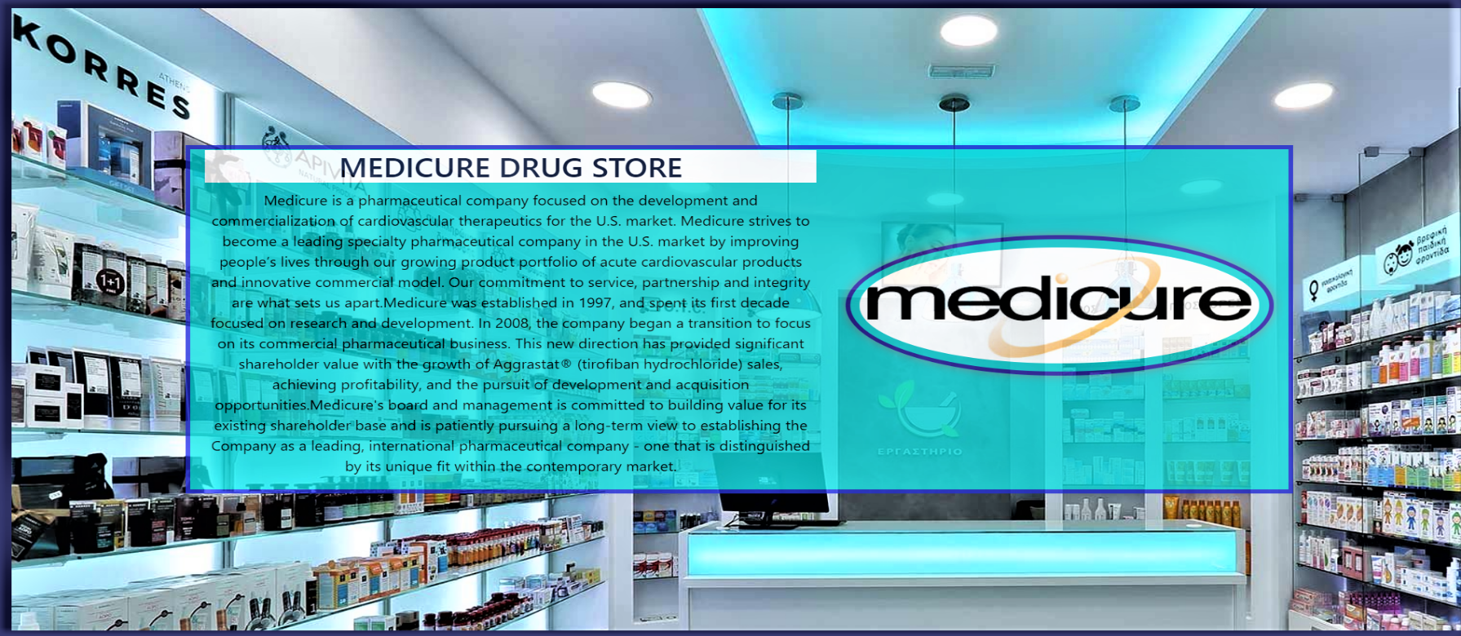

Figure 3: Admin login Page 1.3

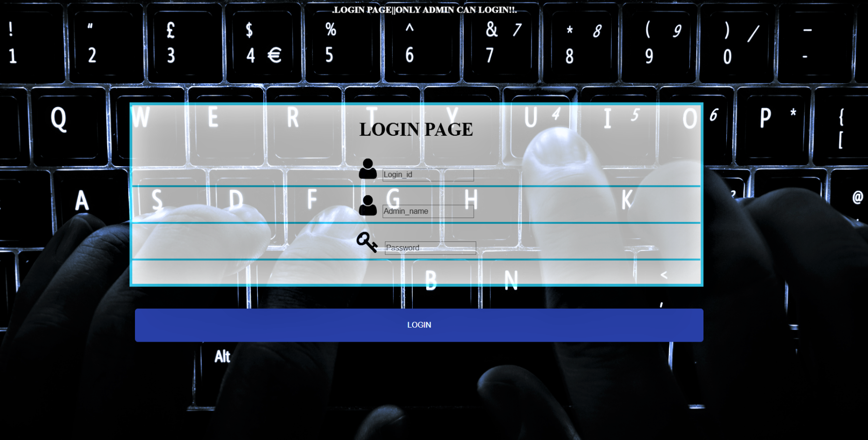

Figure 4: Contact drug store for complaints page 1.4

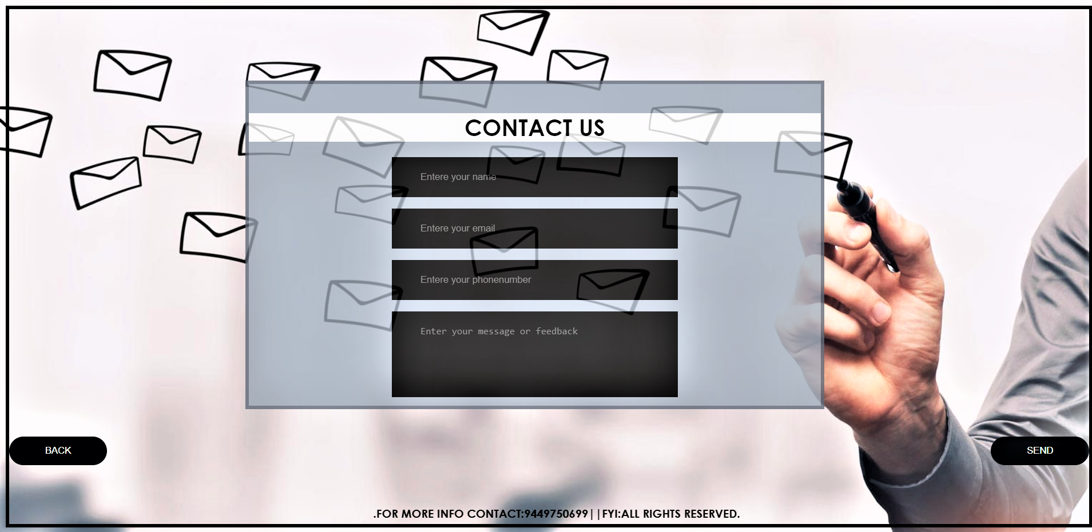

Figure 5: Admin login main page 2.1



Figure 6: Admin search medicine page 3.1

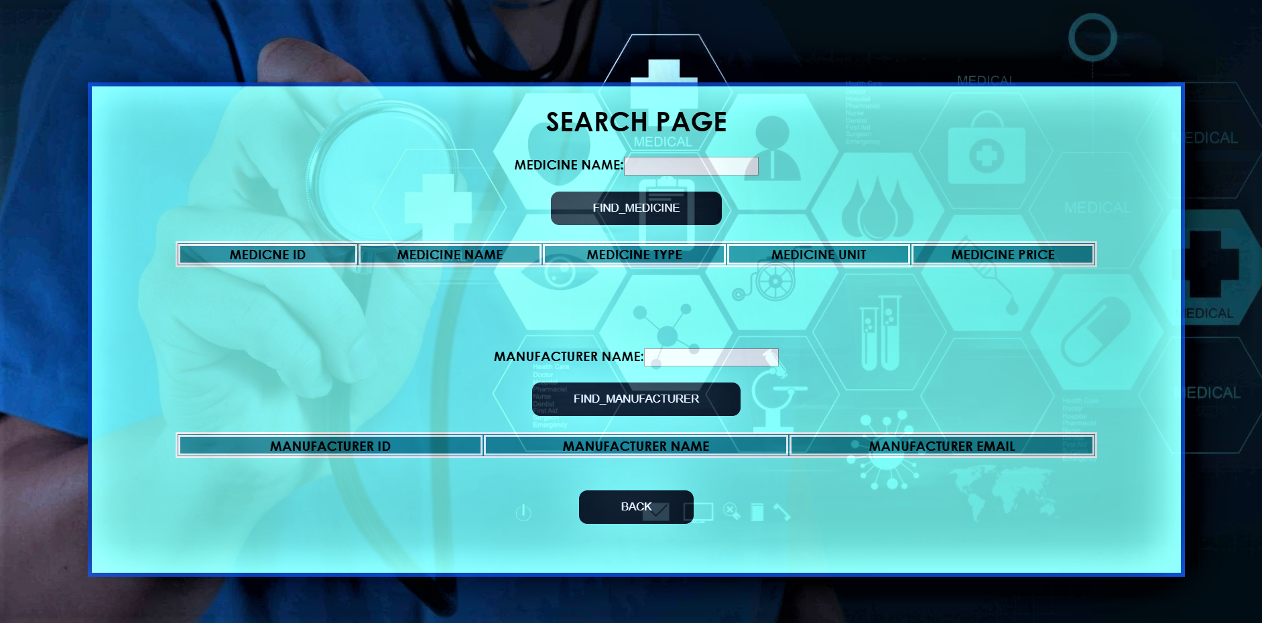

Figure 7: Admin operations(add,delete) page 4.1

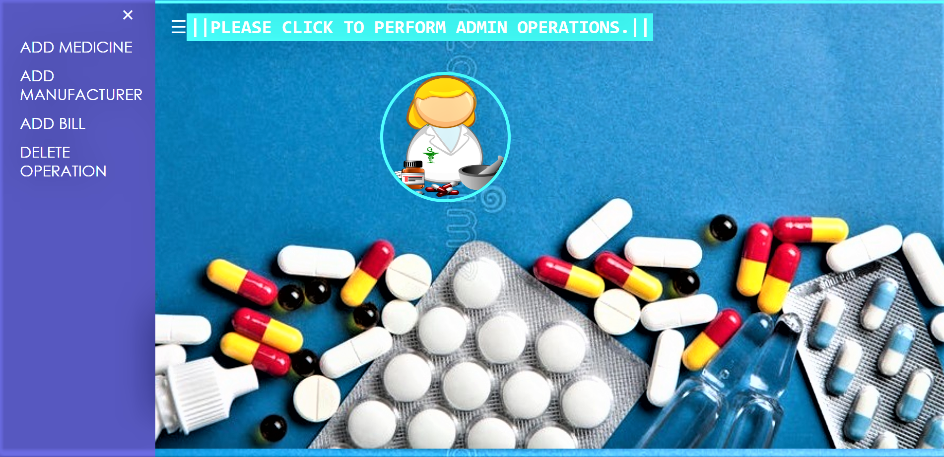

Figure 8: Add medicine page 4.2

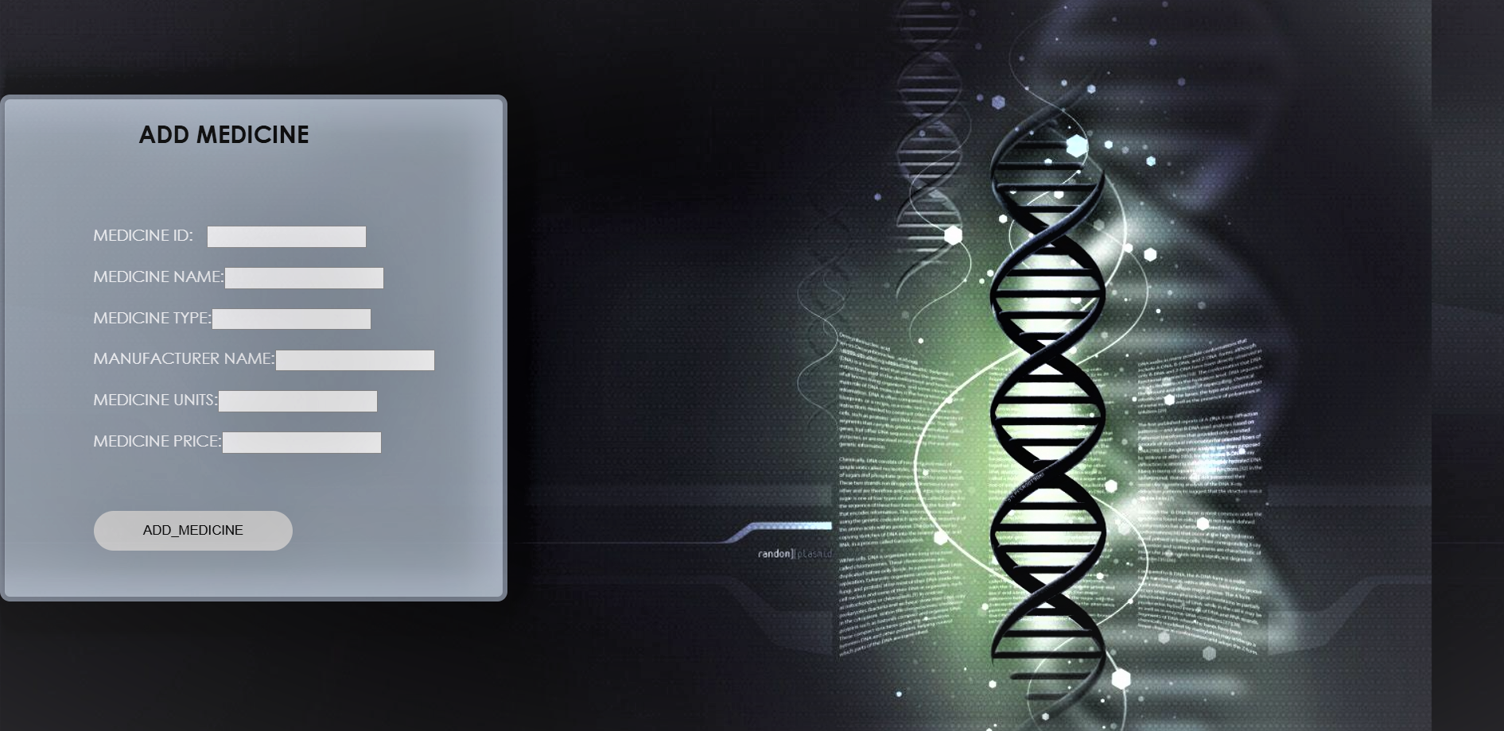

Figure 9: Add manufacturer page 4.3

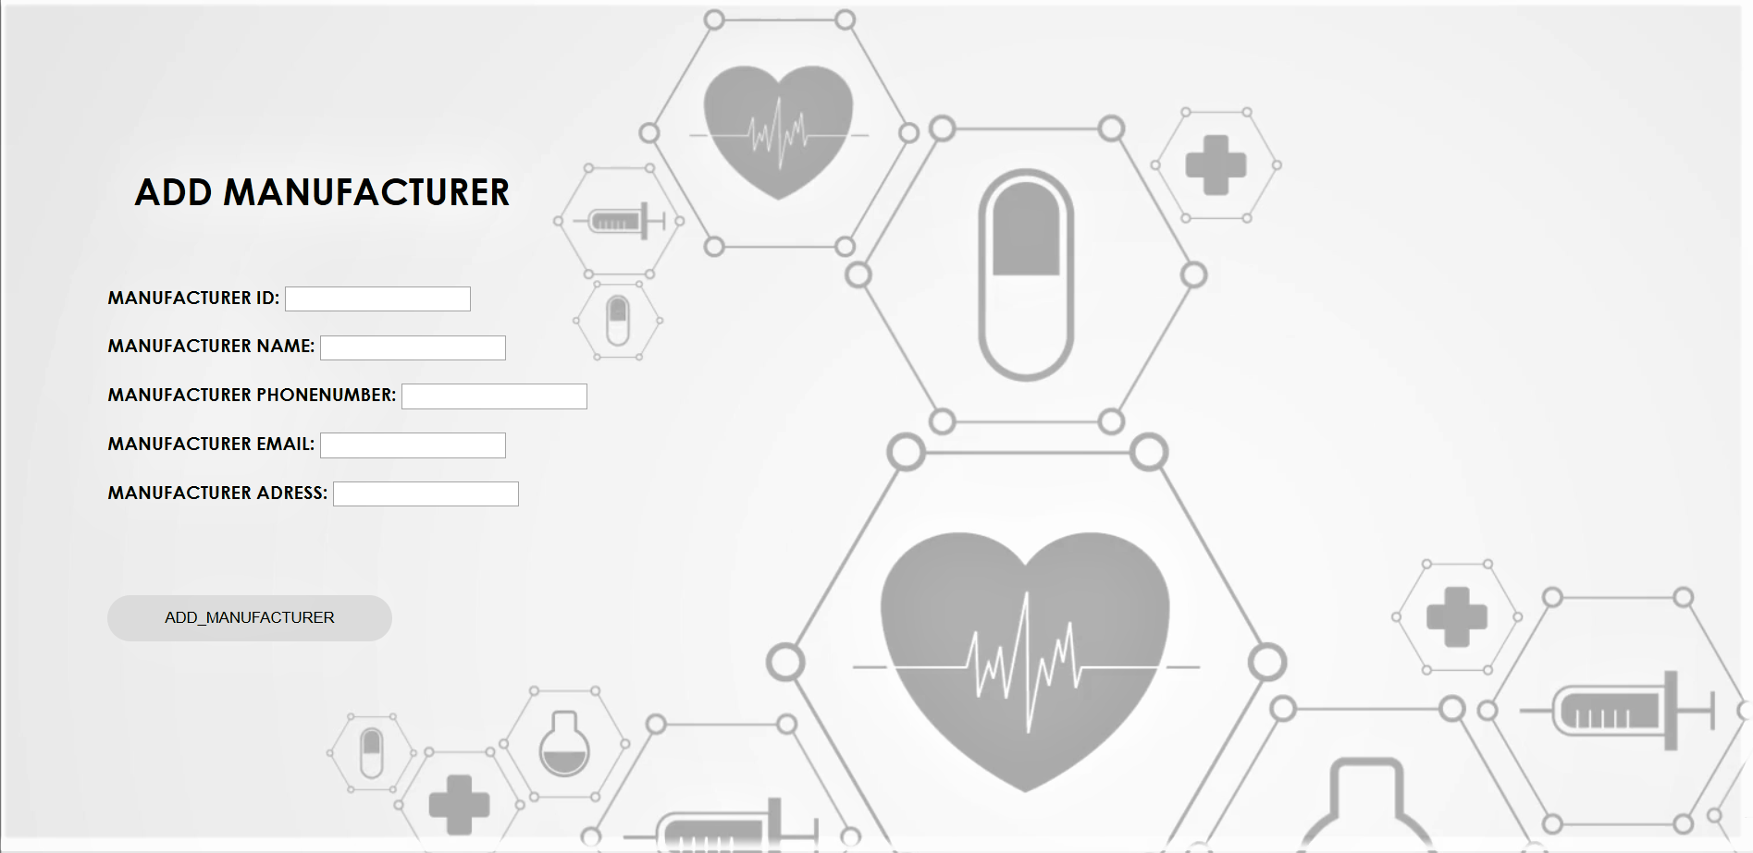

Figure 10: deletion page 4.4

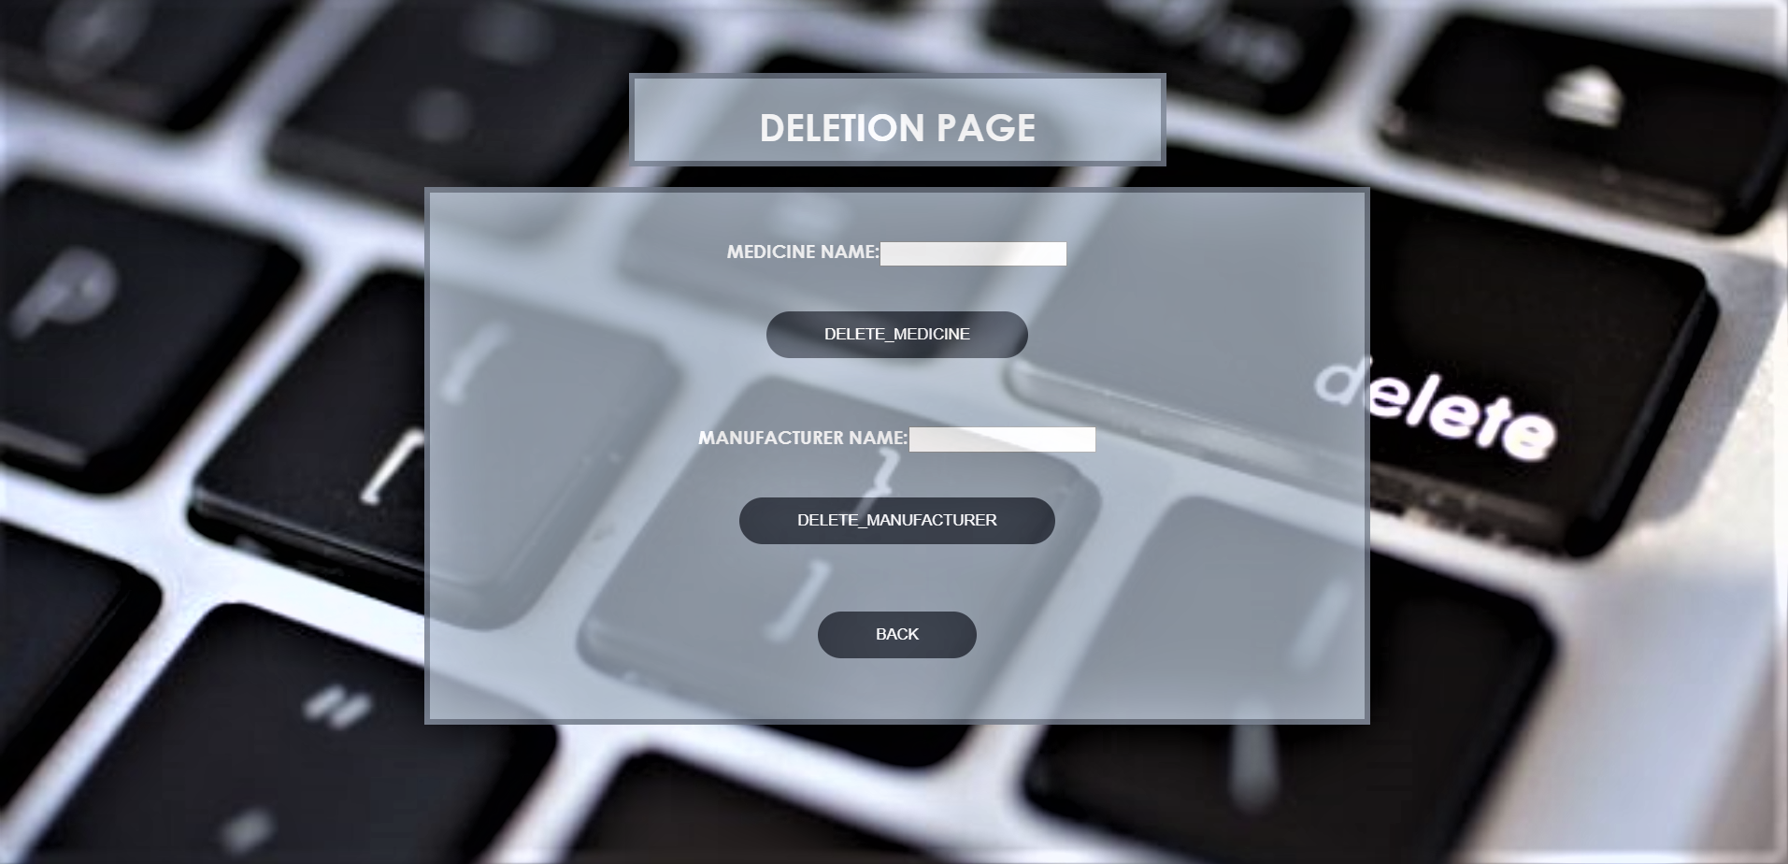

Figure 11: Medicine details page 4.5

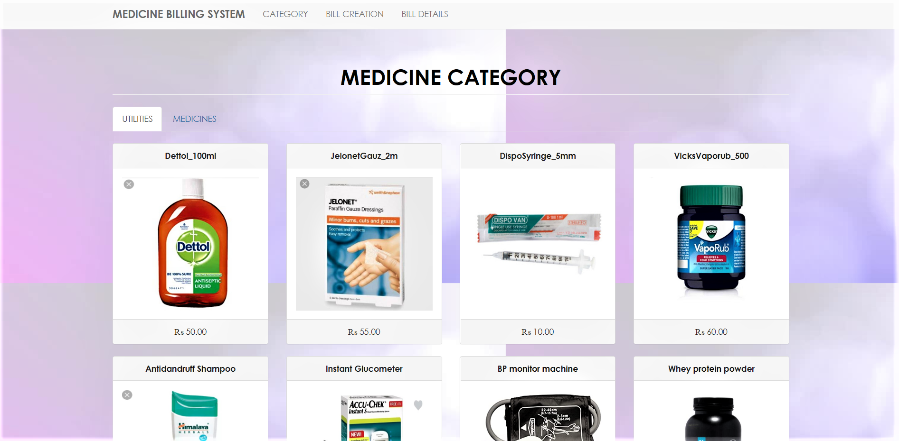

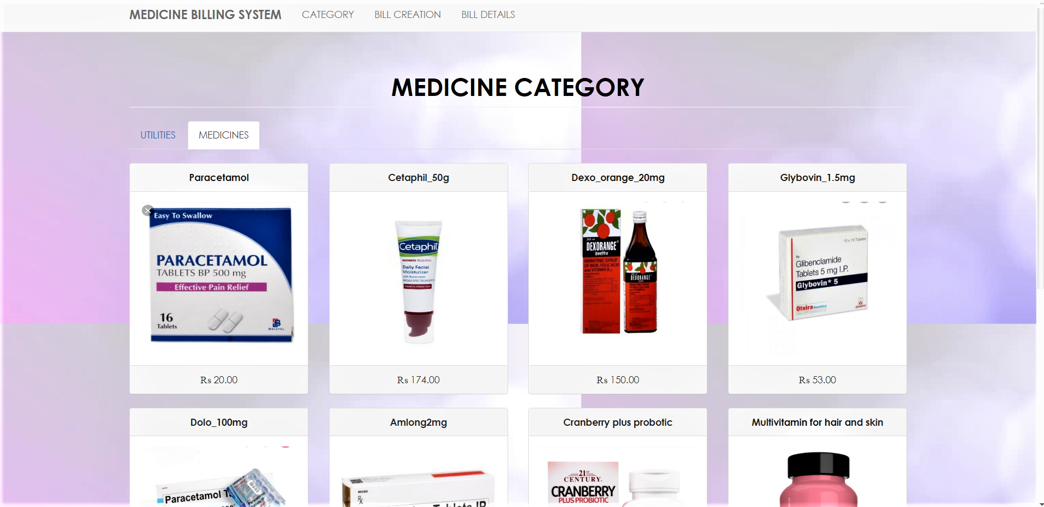

Figure 12: Bill generation page 4.5

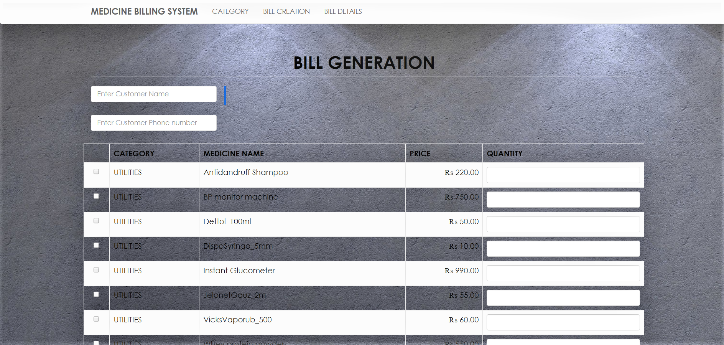

Figure 13: Bill details page 4.6

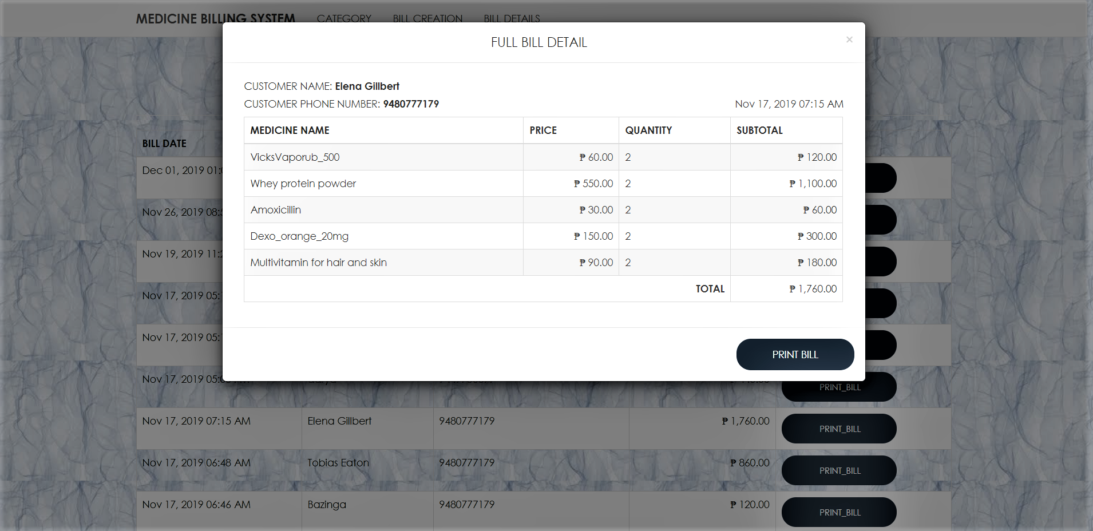

Figure 14: Admin reports access page 5.1

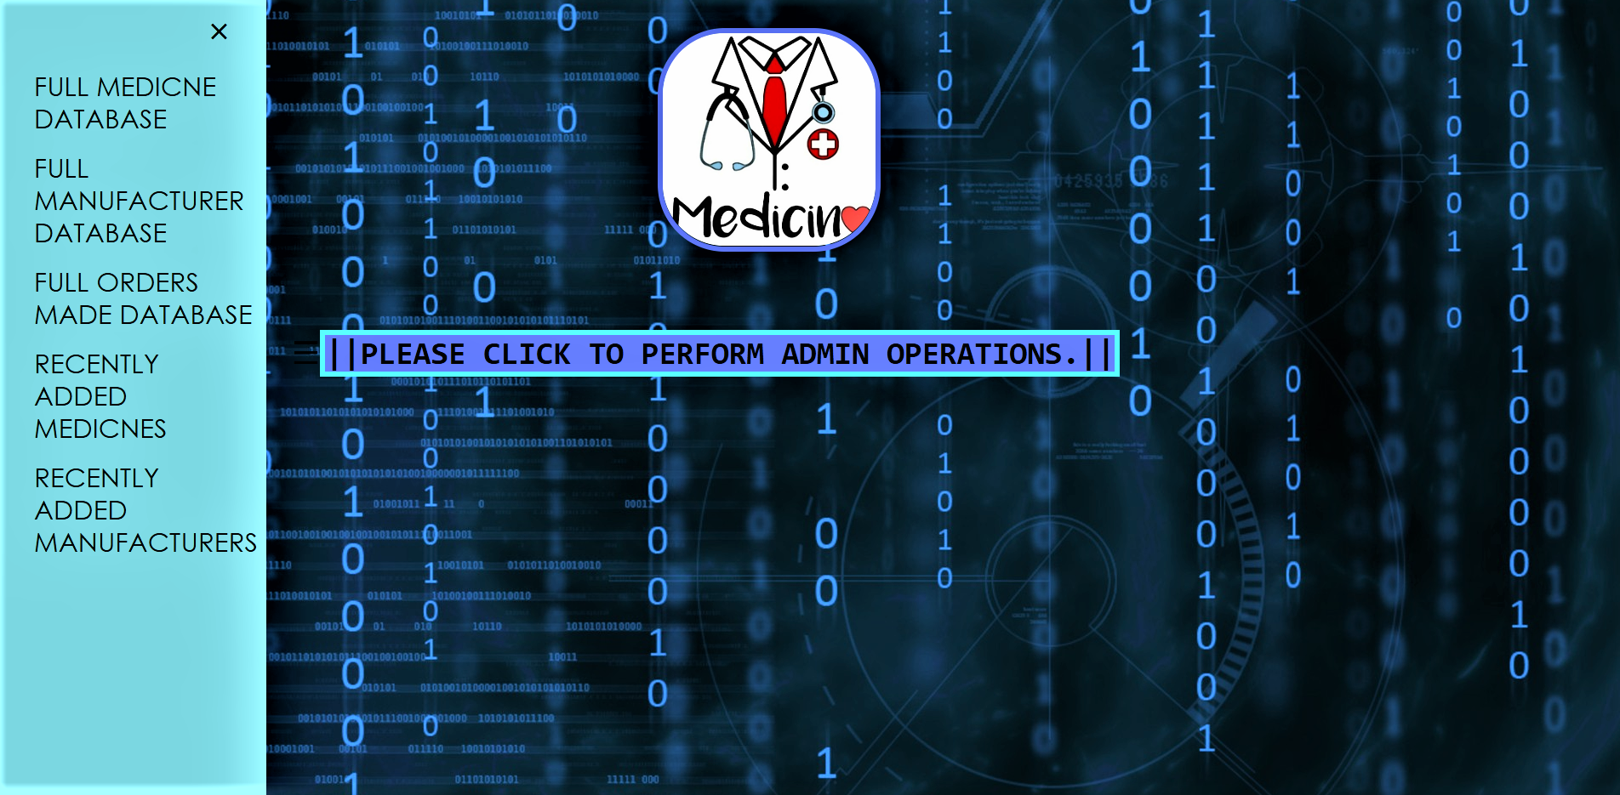

Figure 15: Medicine report page 5.2

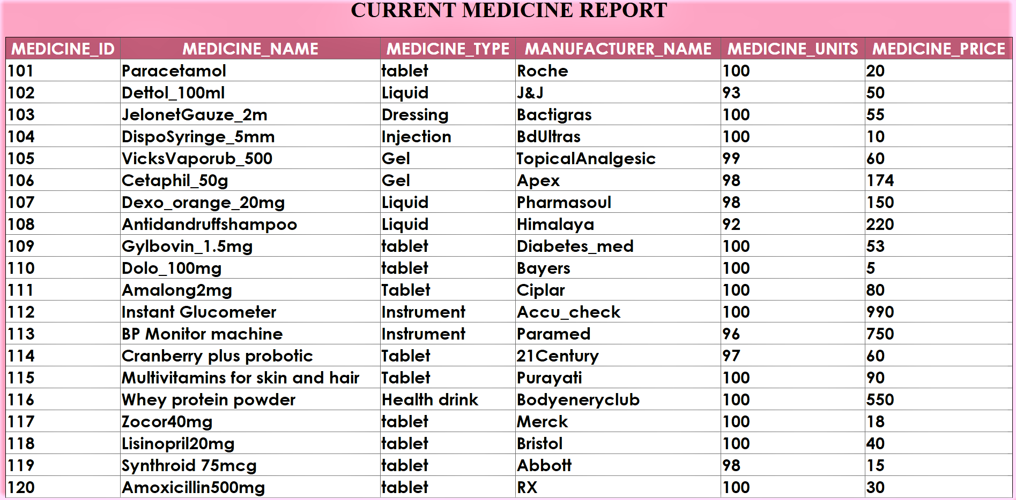

Figure 16: Admin buy medicine for store page 6.1

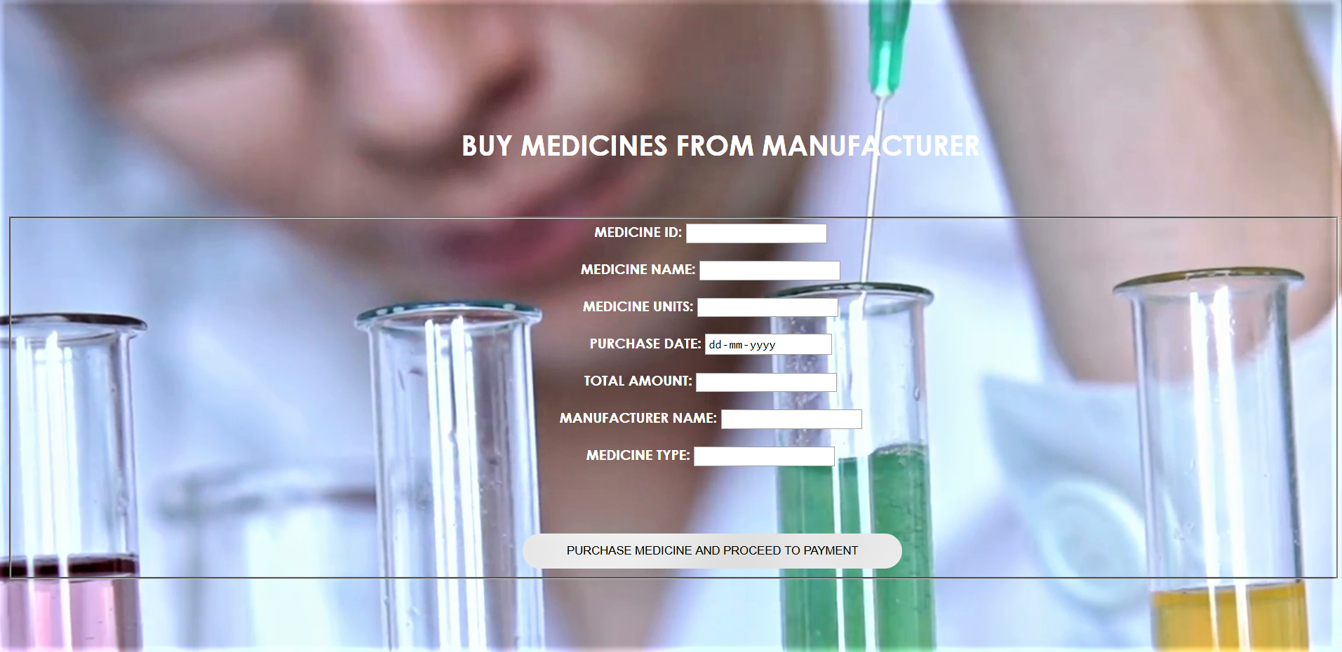

**Chapter 6:**

**TESTING**

* 1. **Introduction to testing**
     + **SOFTWARE TESTING**

Software Testing is a critical element of software quality assurance and represents the ultimate review of specification, design and coding, Testing presents an interesting anomaly for the software engineer.

* Testing Objectives include:

1. Testing is a process of executing a program with the intent of finding an error
2. A good test case is one that has a probability of finding an as yet undiscovered error
3. A successful test is one that uncovers an undiscovered error

* Testing Principles:
  + All tests should be traceable to end user
  + requirements Tests should be planned long before testing begins
  + Testing should begin on a small scale and progress towards testing in large Exhaustive testing is not possible
  + To be most effective testing should be conducted by a independent third party
* Unit Testing:

Unit testing focuses verification effort on the smallest unit of software design that is the module. Using procedural design description as a guide, important control paths are tested to uncover errors within the boundaries of the module. The unit test is normally white box testing oriented and the step can be conducted in parallel for multiple modules.

* Validation Testing:

At the end of integration testing software is completely assembled as a package. Validation testing is the next stage, which can be defined as successful when the software functions in the manner reasonably expected by the customer. Reasonable expectations are those defined in the software requirements specifications.

Information contained in those sections form a basis for validation testing approach.

System Testing:

System testing is actually a series of different tests whose primary purpose is to fully exercise the computer- based system. Although each test has a different purpose, all work to verify that all system elements have been properly integrated to perform allocated functions.

Table 5.1 – System testing

|  |  |  |  |
| --- | --- | --- | --- |
| **Test id** | **Test case** | **Expected result** | **status** |
| 1 | Admin login | Admin login is successfully  authenticated. | pass |
| 2 | Medicines, Manufacturers, Bills details | Is successfully  Entered. | pass |
| 3 | Payment details of medicines bought | Payment details  successfully added. | pass |

**Chapter 7:**

**CONCLUSION**

The conclusion of this project is a ‘**Drug store management System**’ is a computerized management system. The proposed system will keep a track of the list of the medicines, manufacturers and bills with is the main management required for a drug store. This project has GUI based software that will help in retrieving the information through various user- friendly menu-driven modules. The project “Drug Store Management System” is aimed to develop to maintain the data of a drug store.

Overall the project teaches us the essential skills like:

* Using system analysis and design techniques like data flow diagram in designing the system.
* Understanding the database handling and query processing.

2019-20